# Confirmation Email

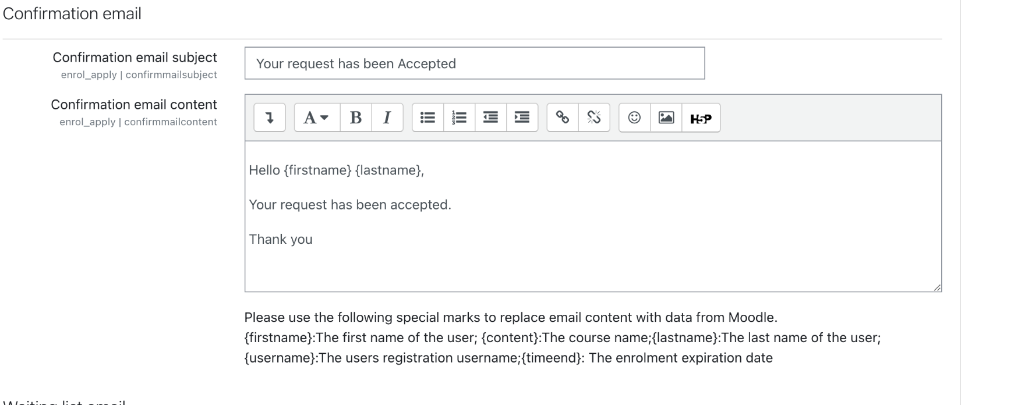

**Customized text:**

# Waiting List Email

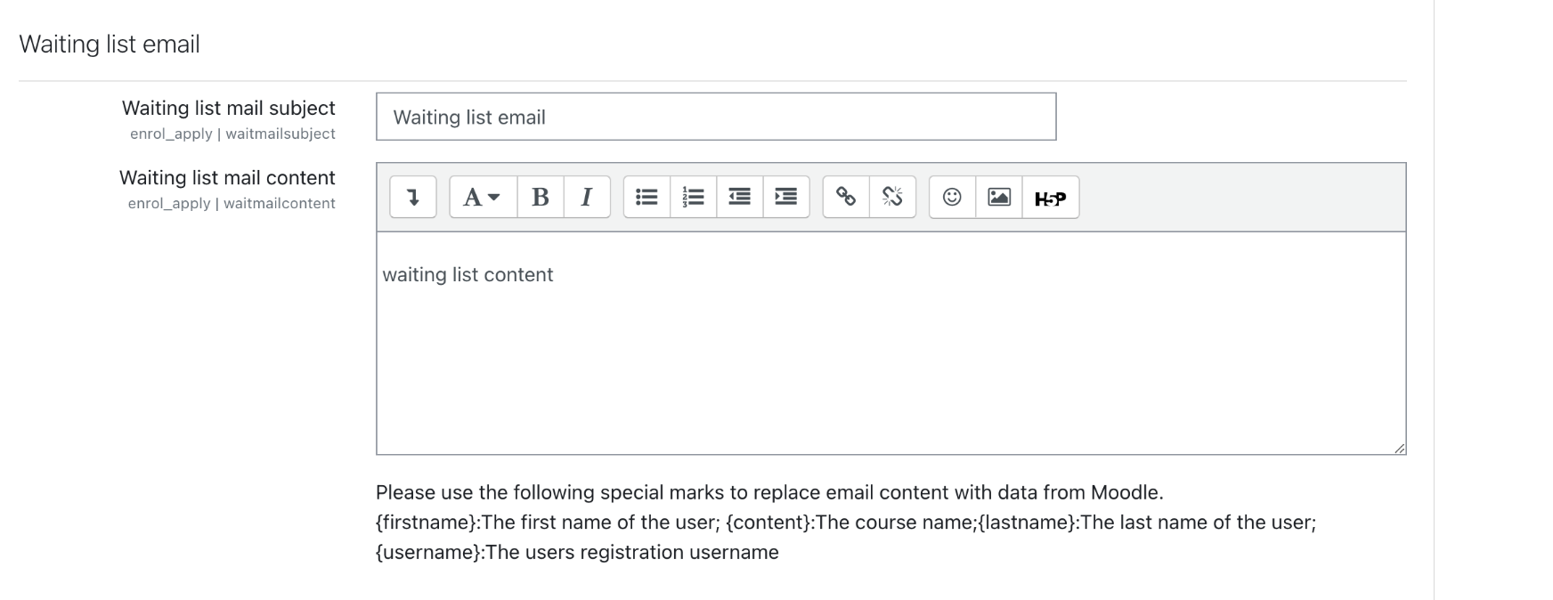

**Customized text:**

# Cancellation Email

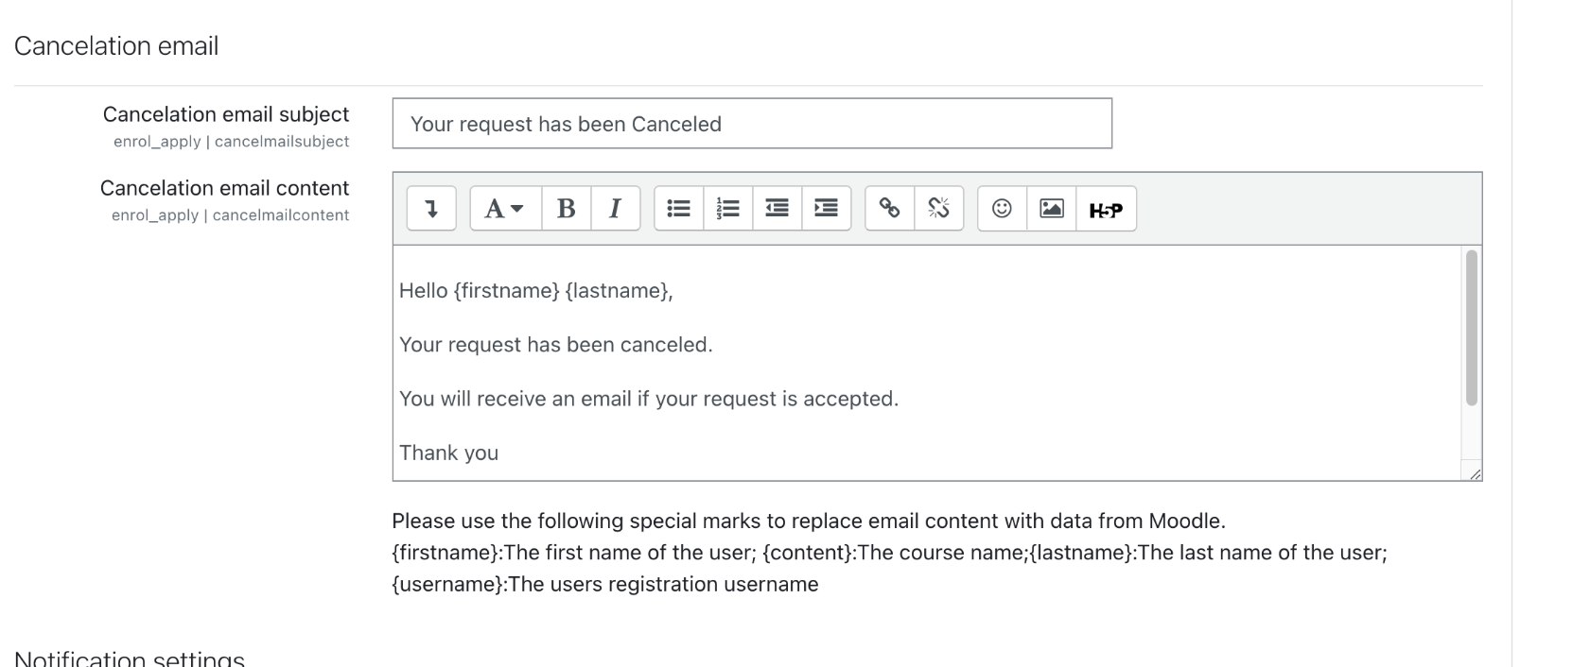

**Customized text:**