Kahoot to Moodle Tutorial

- In the quiz in Kahoot, click the 3 vertical dots.
- Choose Print.
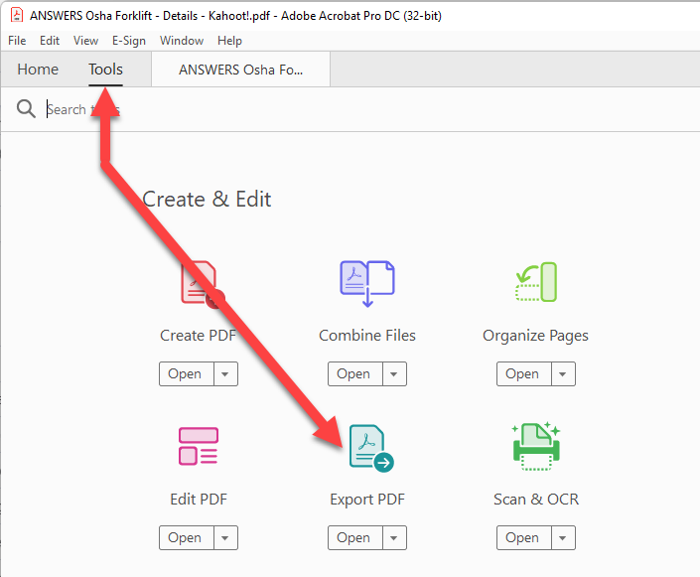
- When the printer window comes up, use the drop-down next to Destination and choose Save as PDF.
- Open the PDF in Adobe Acrobat.
- In the top bar, choose Tools (it should be next to Home in Acrobat).
- Click Export PDF.
- Select Microsoft Word.
- Save the file to your computer.
- Open the Word doc.
- Open Notepad.
- Select all the text in the Word doc and copy it to Notepad. This strips any code in the background.
- Format the file in Notepad. (Aiken is an unnumbered question/statement, next line a capital letter followed by a period, followed by a space and then the choice text. After all choices are listed, next line is all capital letters ANSWER followed by a colon, then a space then the letter of the correct answer.)
Question
A. Choice
B. Choice
ANSWER: A
- Save the file.
- Click the quiz title in Moodle and then click the cog icon on the right.
- Scroll down and choose Import.
- Select Aiken, adjust settings as desired and drop in the .txt file formatted in Notepad.
- After the import, go back to the quiz and add the questions.
- Adjust point value, max score, edit questions as needed.
- Then go back to the quiz settings and set your max score.

